# Section 1

#### Component

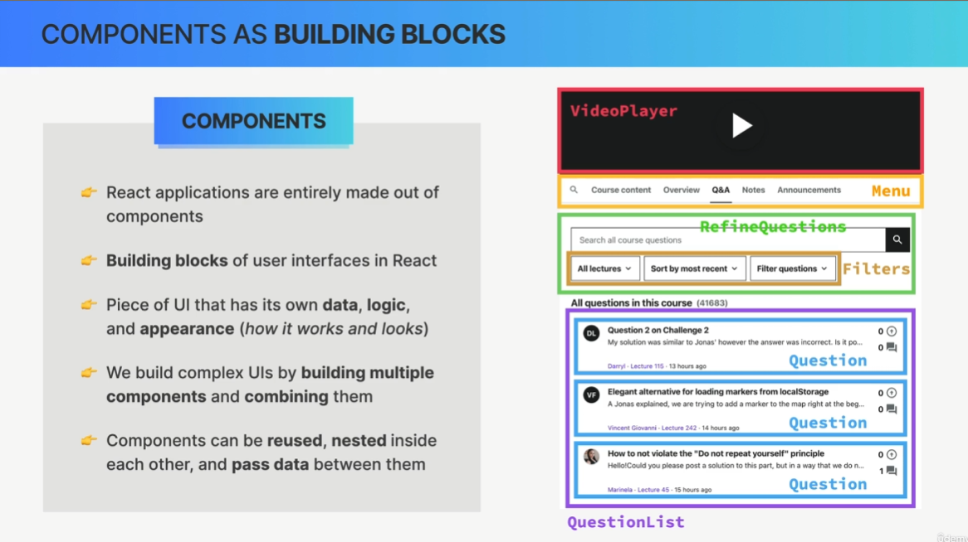

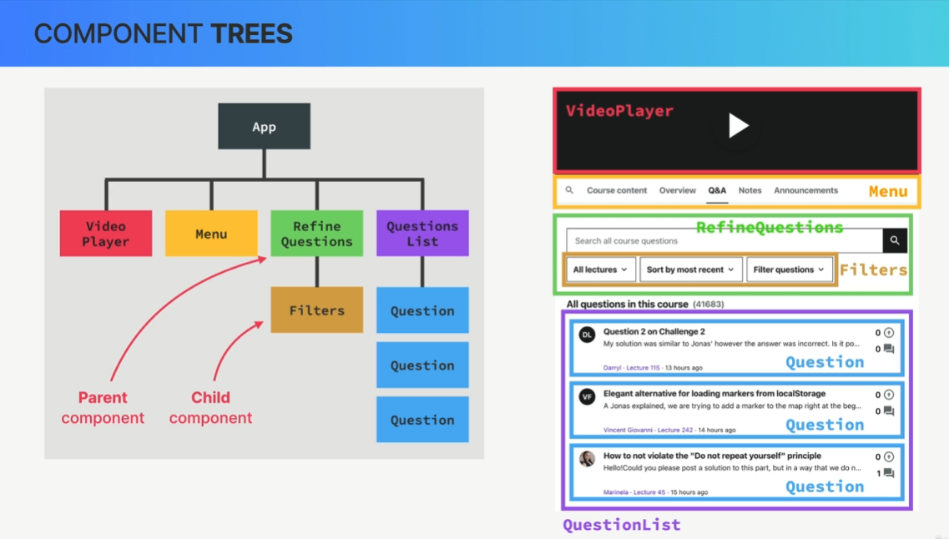

in React is just a function. Now, these functions in React, so these components can return something called JSX, which is a syntax that looks like HTML and describes what we can see on the screen.

##### JSX

It is basically just like HTML, but we can add some JavaScript to it.  
  
- Declarative syntax to describe what components look like and how they work

So when we try to build UIs using vanilla JavaScript, we will by default use an imperative approach. This means that we manually select elements, traverse the DOM, and attach event handlers to elements. Then each time something happens in the app like a click on the button, we give the browser step-by-step instructions on how to mutate those thumb elements until we reach the desired updated UI. So in the imperative approach, we basically tell the browser exactly how to do things.

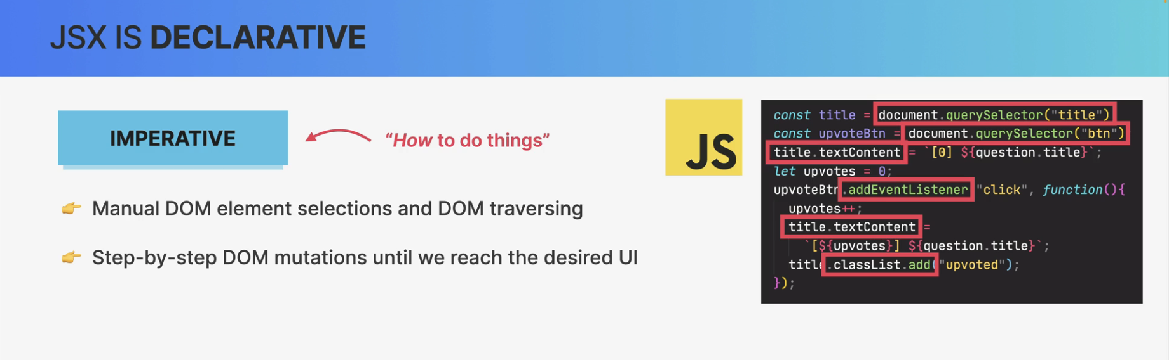

So, a declarative approach is to simply describe what the UI should look like at all times,

always based on the current data that's in the component.

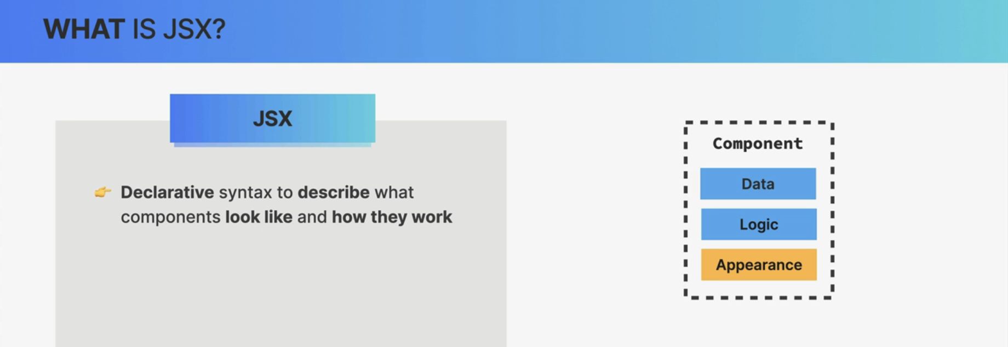

* Components must return a block of JSX

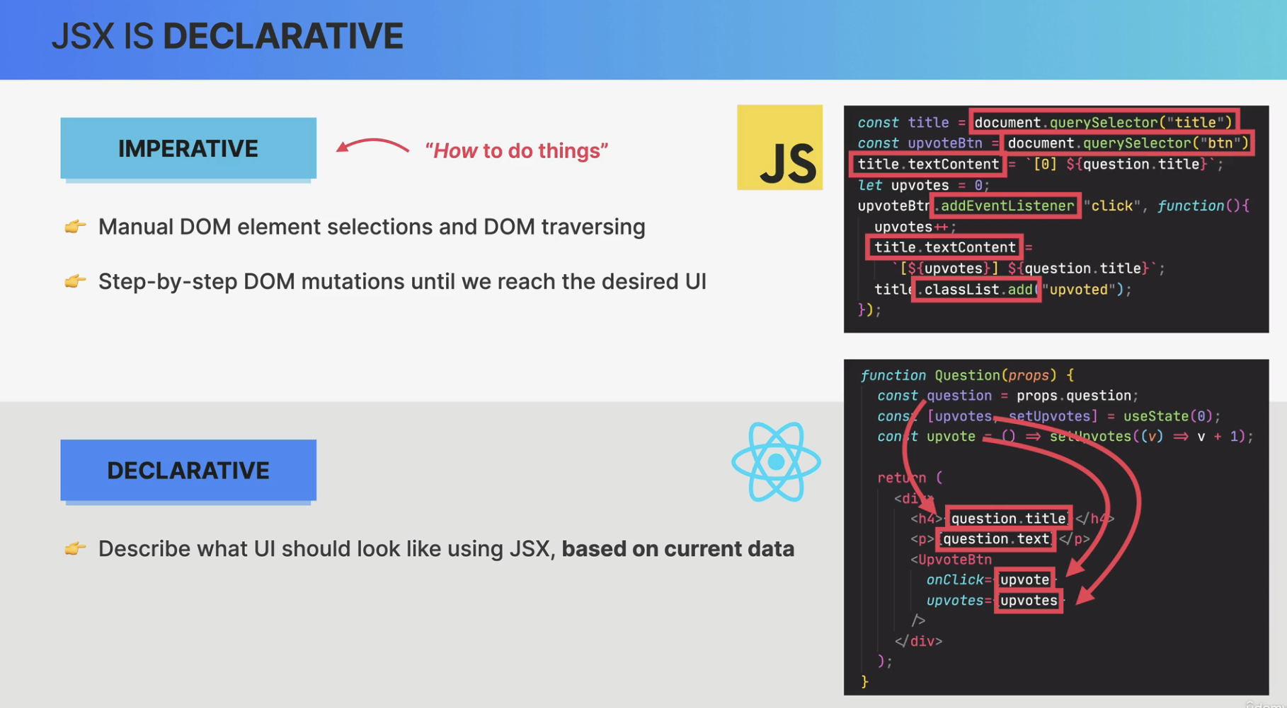

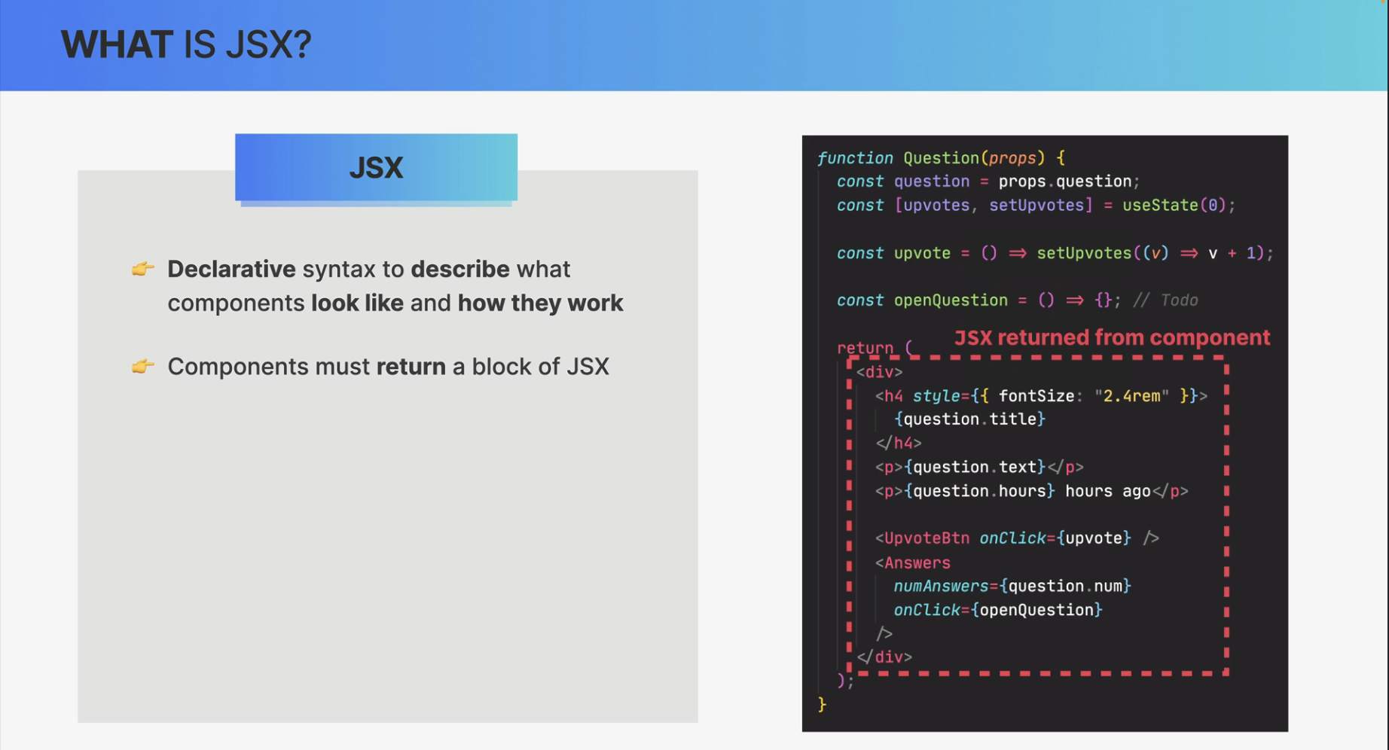

* Extension of JavaScript that allows us to embed JavaScript, CSS, and React components into HTML

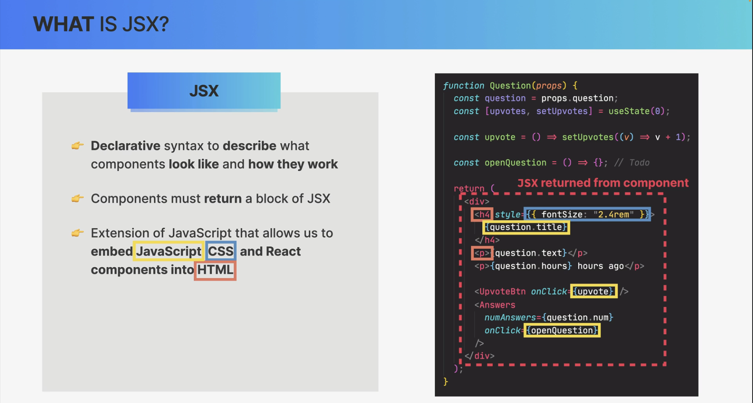

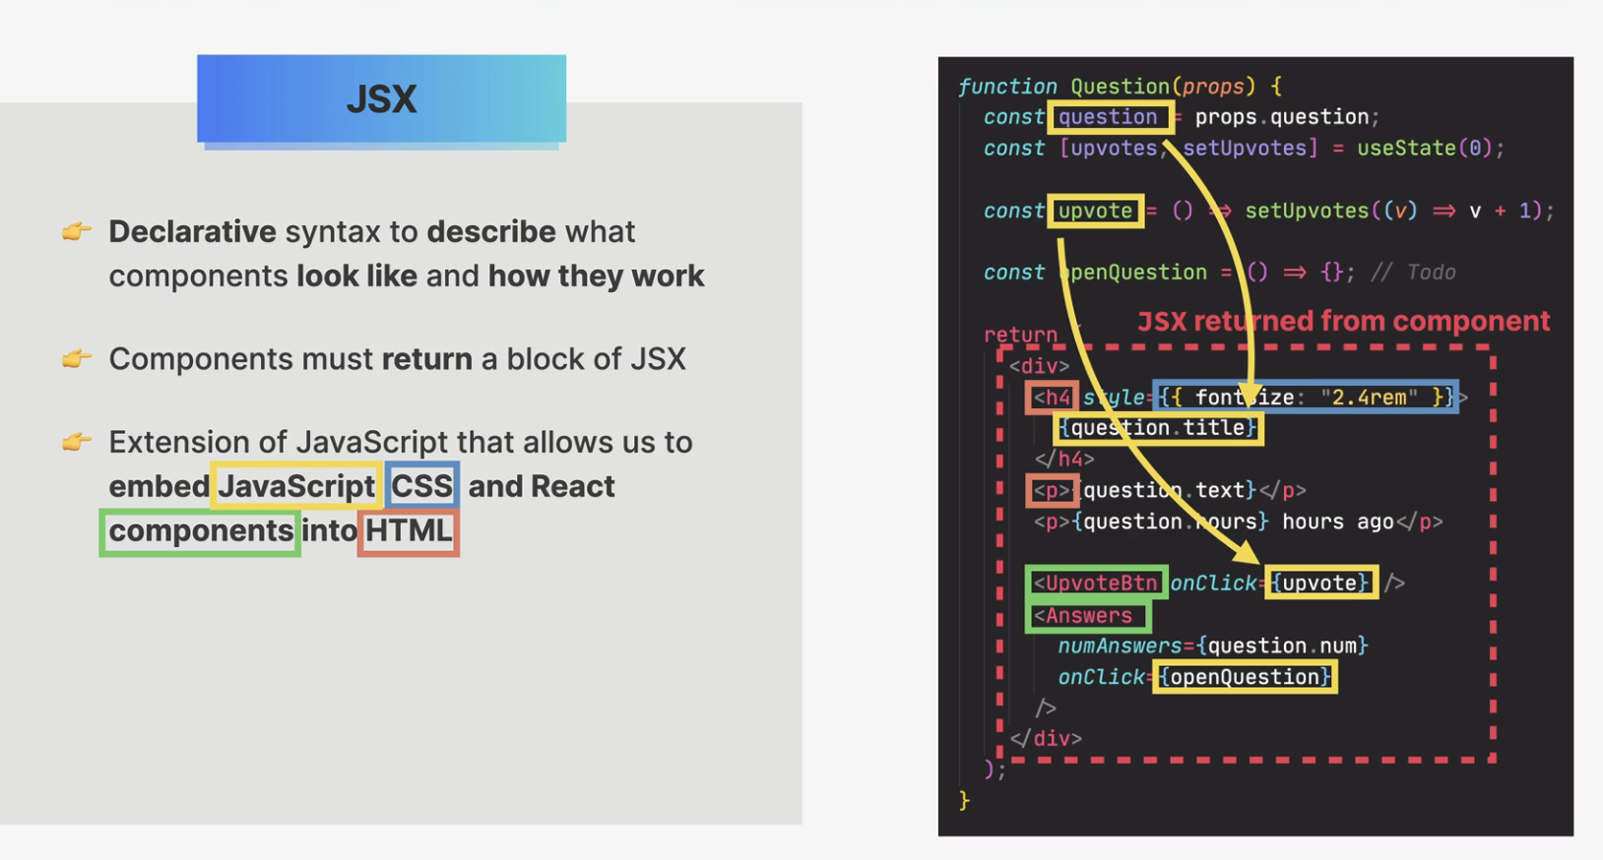

* Each JSX element is converted to a React.createElement function call

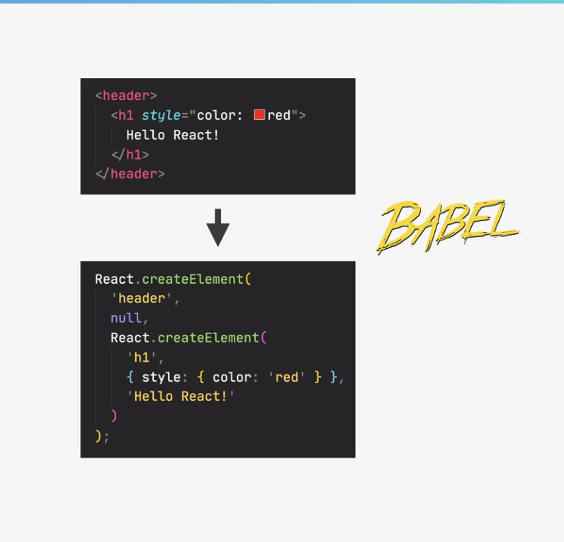

But anyway, this conversion is necessary because browsers of course, do not understand JSX.

They only understand HTML. So behind the scenes, all the JSX that we write is converted into many nested React.createElement function calls. And these function calls are what in the end, create the HTML elements that we see on the screen.

Now, what this means is that we could actually use React without JSX at all.

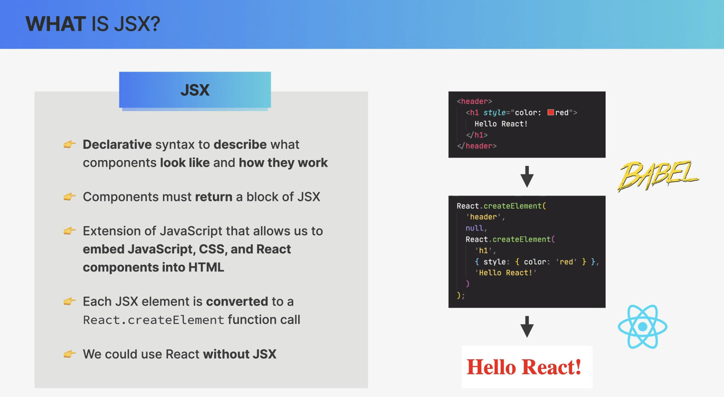

And so again, basically, we use JSX to describe the UI based on props and state. So the data that's currently in the component and all that happens without any DOM manipulation at all.

So, there are no Query selectors, no ad event listeners, no class list, and no text content properties anywhere to be seen here because, in fact, React is basically a huge abstraction away from the DOM, so we, developers never have to touch the DOM directly.

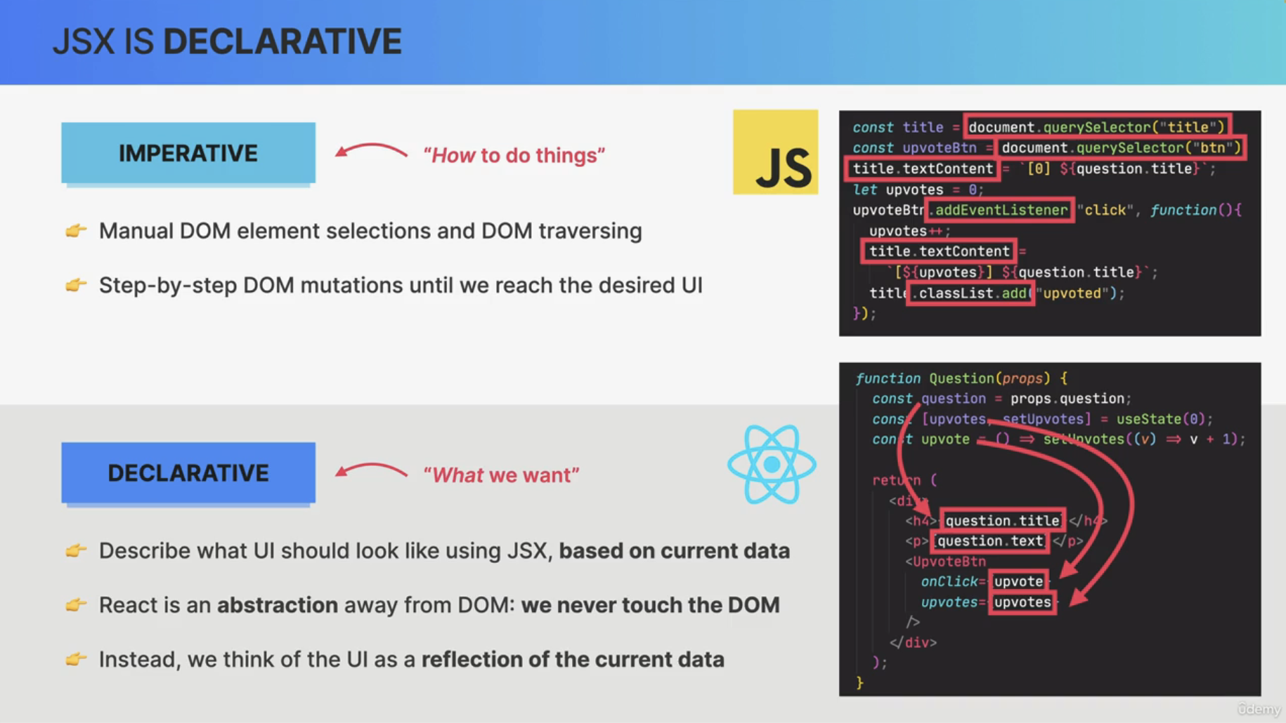

###### Rules of JSX

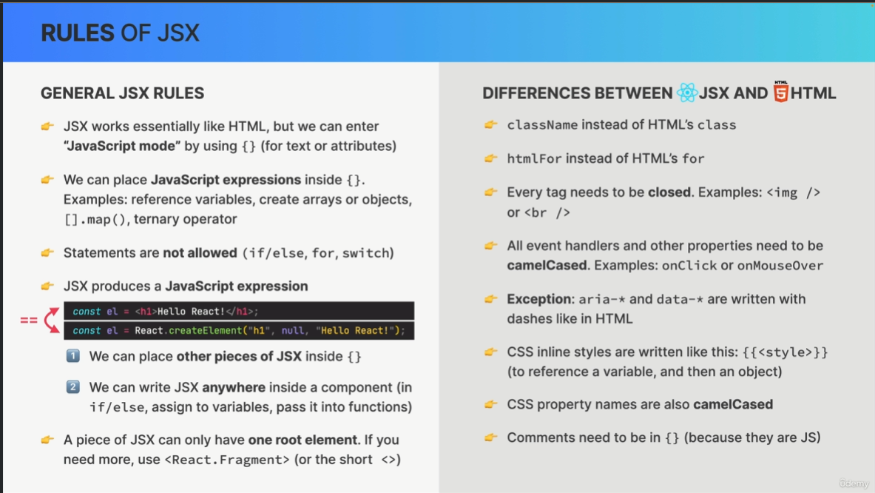

GENERAL JSX RULES

JSX works essentially like HTML, but we can enter

“JavaScript mode” by using {} (for text or attributes)

👉 We can place JavaScript expressions inside {}.

Examples: reference variables, create arrays or objects, [].map(), ternary operator

👉 Statements are not allowed (if/else, for, switch)

👉 JSX produces a JavaScript expression

1⃣ We can place other pieces of JSX inside {}

2⃣ We can write JSX anywhere inside a component (in

if/else, assign to variables, pass it into functions)

==

👉 A piece of JSX can only have one root element. If you

need more, use <React.Fragment> (or the short <>)

DIFFERENCES BETWEEN JSX AND HTML

👉 className instead of HTML’s class

👉 htmlFor instead of HTML’s for

👉 Every tag needs to be closed. Examples: <img />

or <br />

👉 All event handlers and other properties need to be

camelCased. Examples: onClick or onMouseOver

👉 Exception: aria-* and data-* are written with

dashes like in HTML

👉 CSS inline styles are written like this: {{<style>}}

(to reference a variable, and then an object)

👉 CSS property names are also camelCased

👉 Comments need to be in {} (because they are JS)

##### Props

And the prop is basically just like parameters to a function.

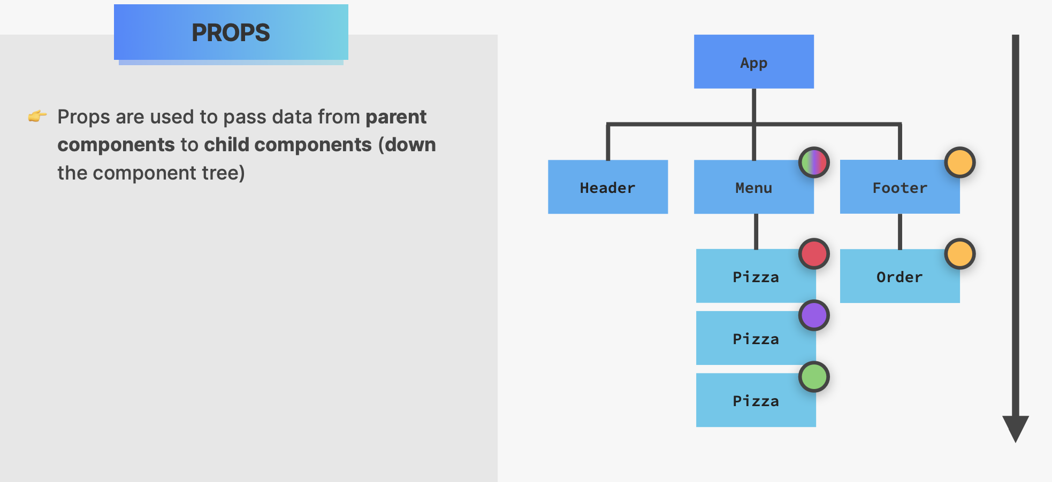

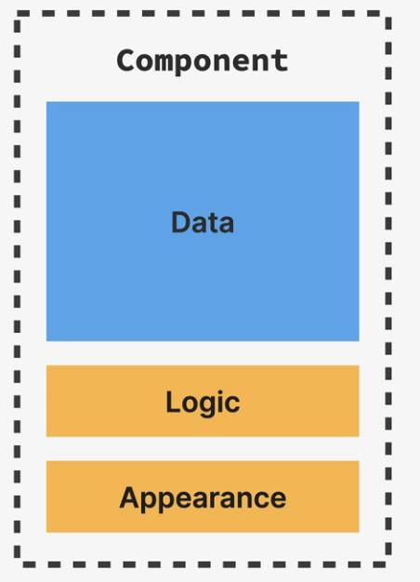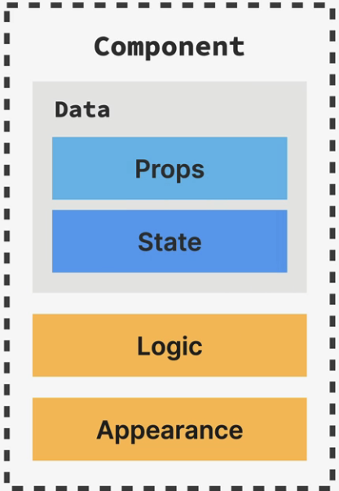

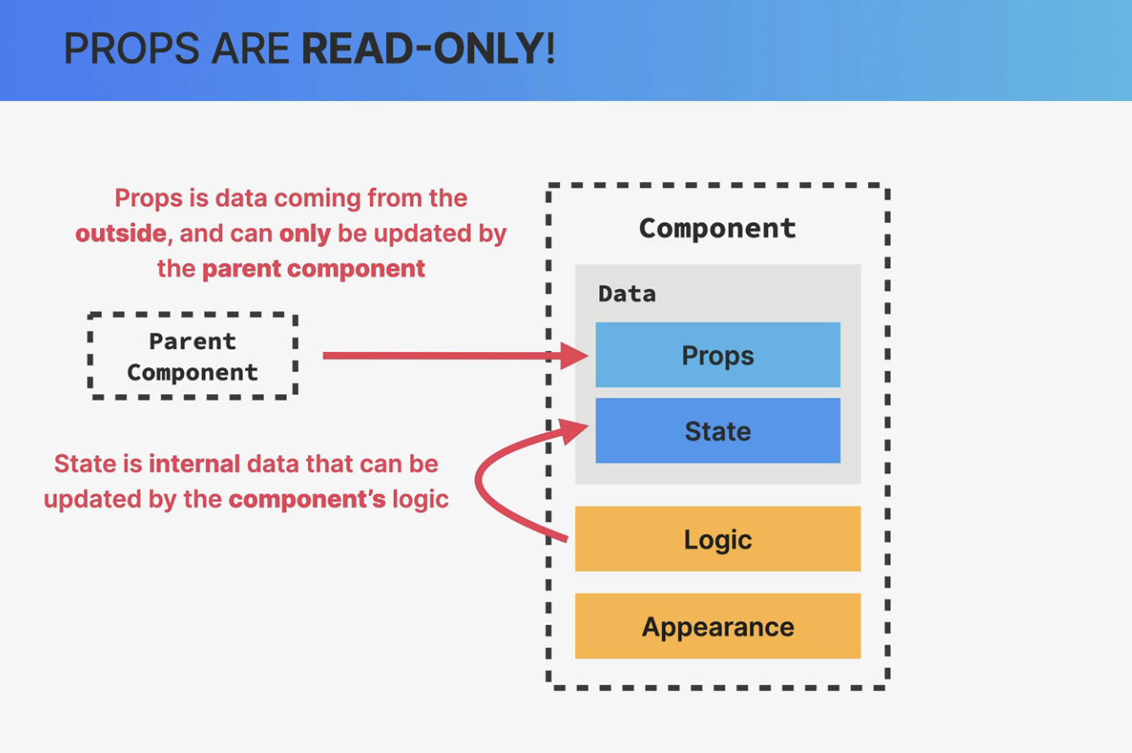

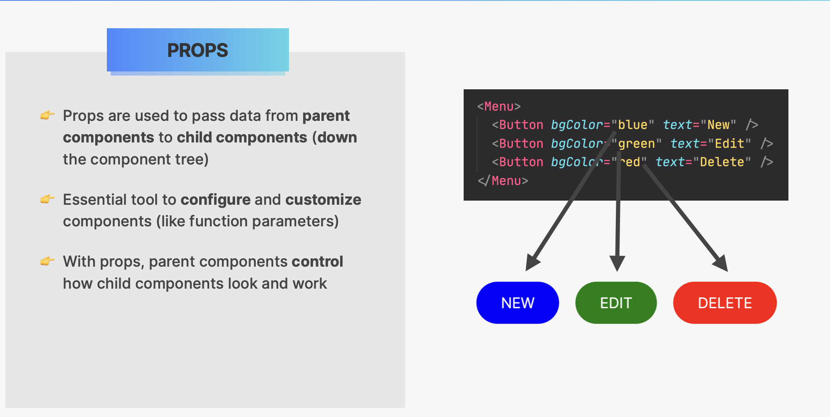

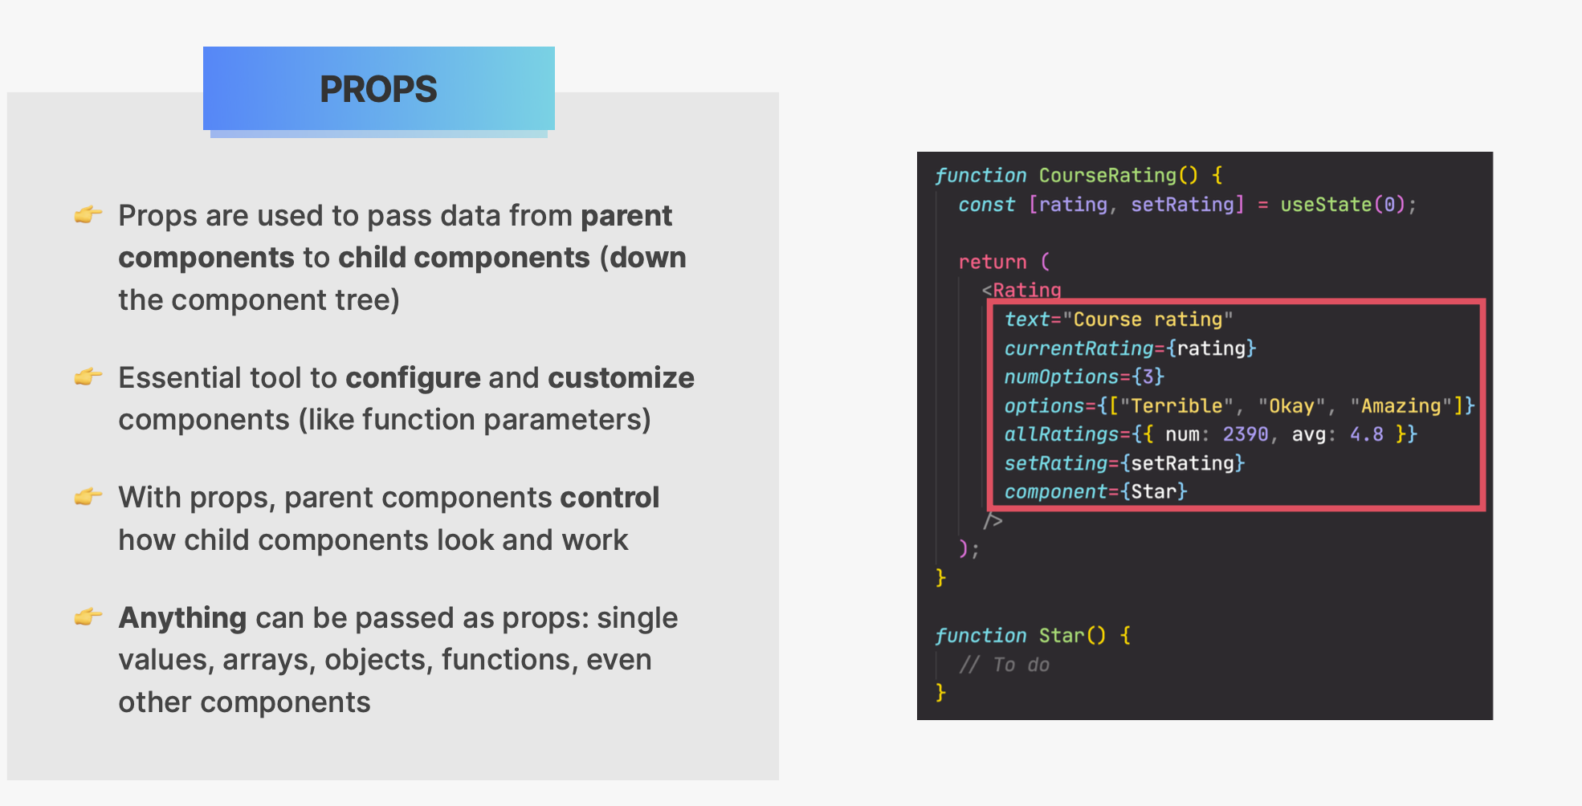

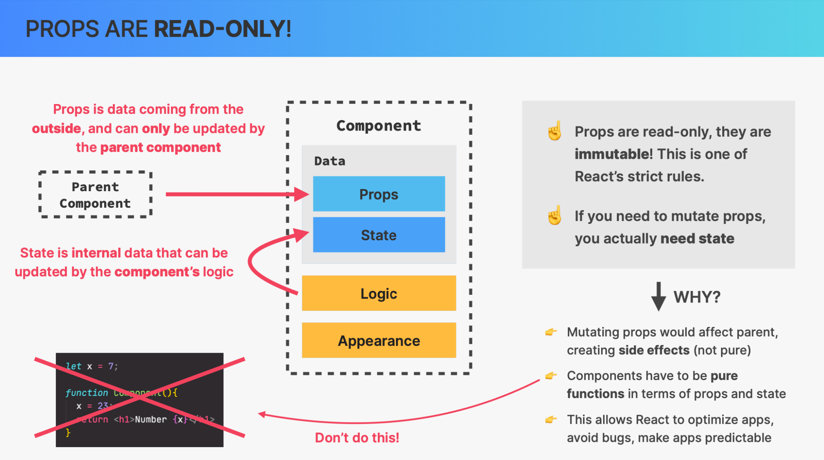

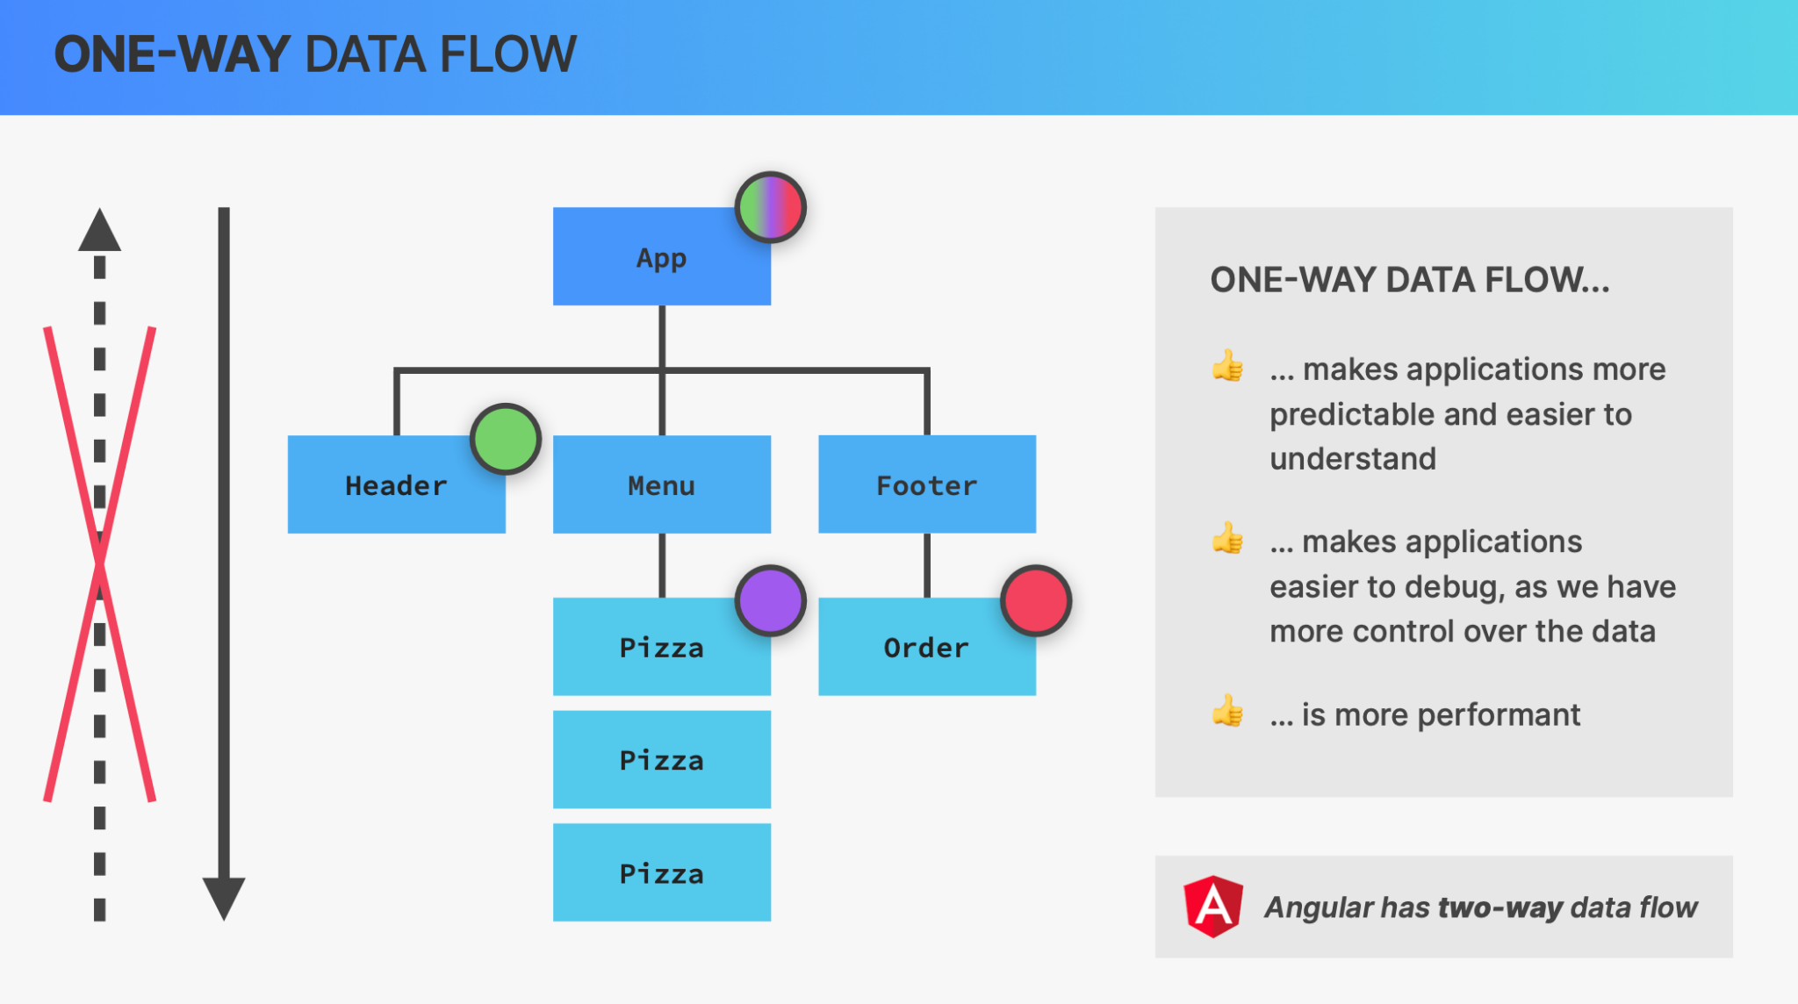

##### Rendering List

| const pizzaData = [  {  name: "Focaccia",  ingredients: "Bread with italian olive oil and rosemary",  price: 6,  photoName: "pizzas/focaccia.jpg",  soldOut: false,  },  {  name: "Pizza Margherita",  ingredients: "Tomato and mozarella",  price: 10,  photoName: "pizzas/margherita.jpg",  soldOut: false,  }, ]; |
| --- |

| <ul className="pizzas">  {pizzaData.map((pizza) => (  <Pizza key={pizza.name} pizzaObj={pizza} />  ))} </ul>; |
| --- |

| function Pizza(props) {  return (  <li className="pizza">  <img src={props.pizzaObj.photoName} alt={props.pizzaObj.name} />  <div>  <h3>{props.pizzaObj.name}</h3>  <p>{props.pizzaObj.ingredients}</p>  <span>{props.pizzaObj.price}</span>  </div>  </li>  ); } |
| --- |

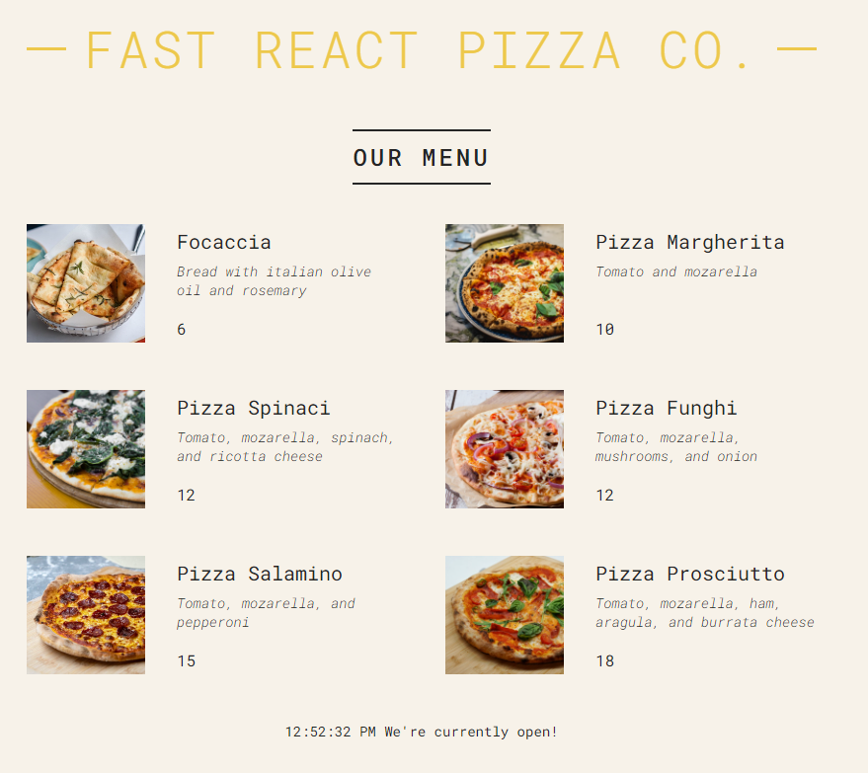

###### Conditional Rendering &&

| function Menu() {  const pizzas = pizzaData;  const numPizzas = pizzas.length;  return (  <main className="menu">  <h2>Our Menu</h2>   {numPizzas > 0 && (  <ul className="pizzas">  {pizzaData.map((pizza) => (  <Pizza key={pizza.name} pizzaObj={pizza} />  ))}  </ul>  )}  </main>  ); } |
| --- |

Be careful here numPizzas > 0 -> the value from the expression must be true or false. If the result of the expression is 0, then 0 will be displayed on the UI.  
  
For example if the check is

| {numPizzas && (  <ul className="pizzas">  {pizzaData.map((pizza) => (  <Pizza key={pizza.name} pizzaObj={pizza} />  ))}  </ul>  )} |
| --- |

Then if the numPizzas is 0, then the second condition will not executed at all, but the first expression which is numPizzas will give 0 as a result and then the 0 will be displayed on the UI. True, or false values are not displayed on the UI.

###### Conditional Rendering ?

| function Menu() {  const pizzas = pizzaData;  // const pizzas = [];  const numPizzas = pizzas.length;  return (  <main className="menu">  <h2>Our Menu</h2>   {numPizzas > 0 ? (  <ul className="pizzas">  {pizzaData.map((pizza) => (  <Pizza key={pizza.name} pizzaObj={pizza} />  ))}  </ul>  ) : (  <p>We are still working on our menu. Please come back later</p>  )}  </main>  ); } |
| --- |

#### 

| function Footer() {  const hour = new Date().getHours();  const openHour = 12;  const closeHour = 22;  const isOpen = hour >= openHour && hour <= closeHour;   return (  <footer className="footer">  {isOpen ? (  <div className="order">  <p>We'are open until {closeHour}:00. Come visit us or order online</p>  <button className="btn">Order</button>  </div>  ) : (  <p>  We are happy to wellcome you between {openHour}:00 and {closeHour}:00  </p>  )}  </footer>  ); } |
| --- |

###### Conditional Rendering With Multiple Returns

//useful when we want to render full components , no some piece of JSX

| if (!isOpen)  return (  <p>  We are happy to wellcome you between {openHour}:00 and {closeHour}:00  </p>  ); |
| --- |

#### 

| function Pizza(props) {  if (props.pizzaObj.soldOut) return null;   return (  <li className="pizza">  <img src={props.pizzaObj.photoName} alt={props.pizzaObj.name} />  <div>  <h3>{props.pizzaObj.name}</h3>  <p>{props.pizzaObj.ingredients}</p>  <span>{props.pizzaObj.price}</span>  </div>  </li>  ); } |
| --- |

###### Setting Classes and Text Conditionally

| function Pizza({ pizzaObj }) {  return (  // <li className={"pizza " + (pizzaObj.soldOut ? "sold-out" : "")}>  // <li className={`pizza ${pizzaObj.soldOut && "sold-out"}`}>  <li className={`pizza ${pizzaObj.soldOut ? "sold-out" : ""}`}>  <img src={pizzaObj.photoName} alt={pizzaObj.name} />  <div>  <h3>{pizzaObj.name}</h3>  <p>{pizzaObj.ingredients}</p>  <span>{pizzaObj.soldOut ? "SOLD OUT" : pizzaObj.price}</span>  </div>  </li>  ); } |
| --- |

##### React Fragments

| function Menu() {  const pizzas = pizzaData;  // const pizzas = [];  const numPizzas = pizzas.length;  return (  <main className="menu">  <h2>Our Menu</h2>   {numPizzas > 0 ? (  <>  <p>  Authentic Italian cuisine. 6 creative dishes to choose from. All  from our stone oven, all organic, all drlicious  </p>  <ul className="pizzas">  {pizzaData.map((pizza) => (  <Pizza key={pizza.name} pizzaObj={pizza} />  ))}  </ul>  </>  ) : (  <p>We are still working on our menu. Please come back later</p>  )}  </main>  ); } |
| --- |

If we need to put key attribute on the fragment the we must use this syntax

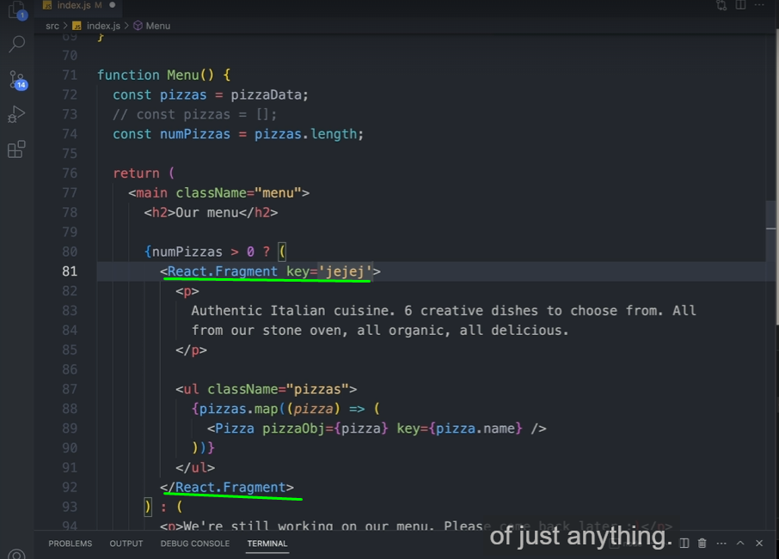

#### Separation of concerns

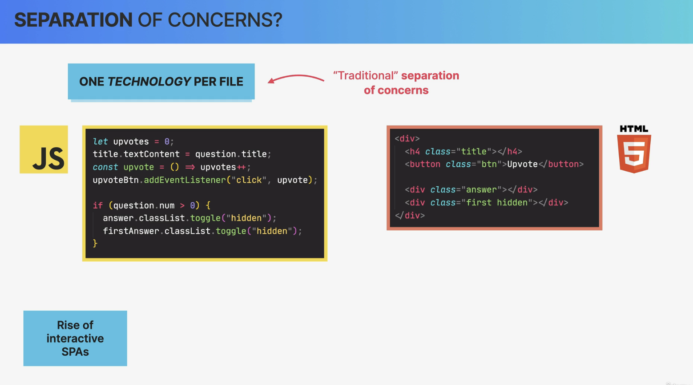

#### 

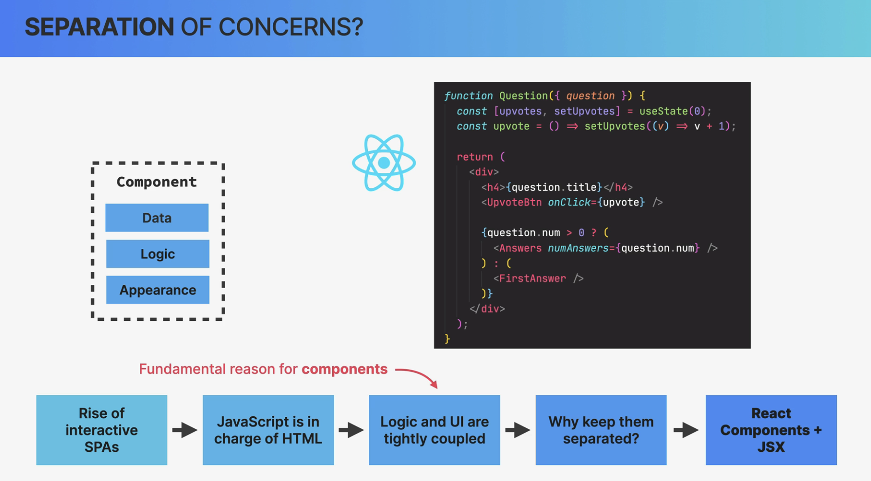

So content and logic are tightly coupled together and so it makes sense that they are co-located here.

Co-located simply means that things that change together should be located as close as possible together.

And in the case of React apps, that means that instead of one technology profile, we have one component profile. So one component that contains data logic and appearance,

all mixed together.

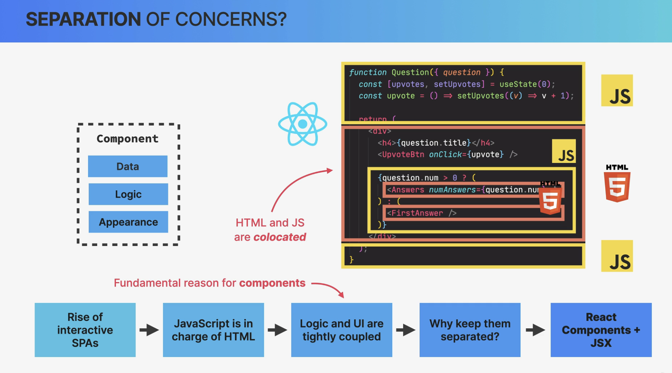

Well, I think that the people who say that React has no separation of concerns, got it all wrong.

Because React does actually have a separation of concerns. It's just not one concern per file,

as we had traditionally but one concern per component.

So each component is in fact, only concerned with one piece of the UI.

Then within each of these components, of course we still have the three concerns of HTML, CSS, and JavaScript all mixed up, as we have been discussing.

So compared to the traditional separation of concerns, this is a completely new paradigm that many people were really not used to in the beginning. But now, many years later, we all got used to this and it works just great.

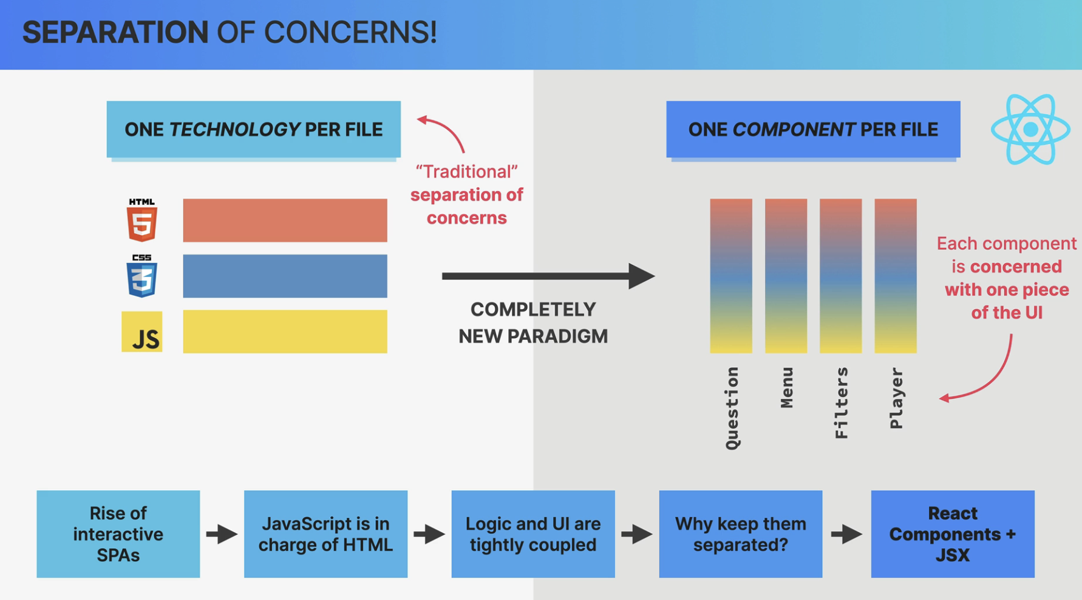

#### State

And the state is the most fundamental concept of React. So whenever we need something to change in the user interface, we change the state. So we update something that we call state.

##### 

##### 

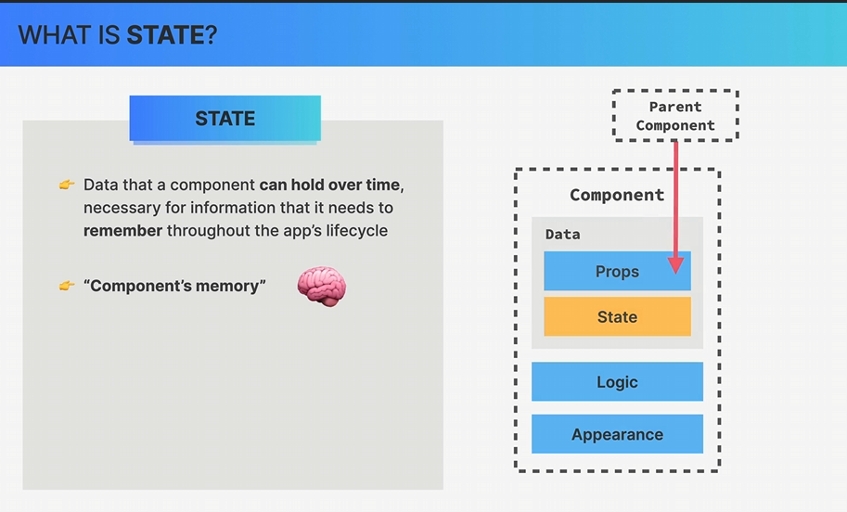

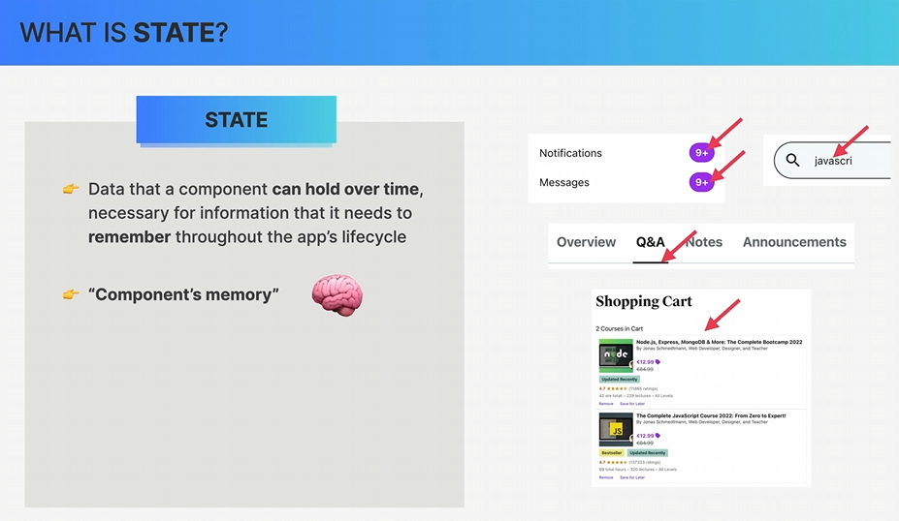

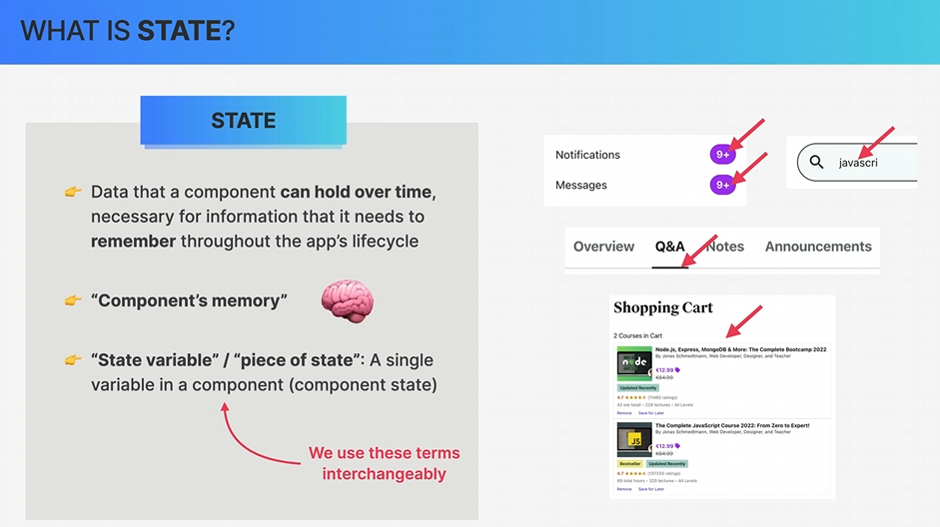

##### 

##### 

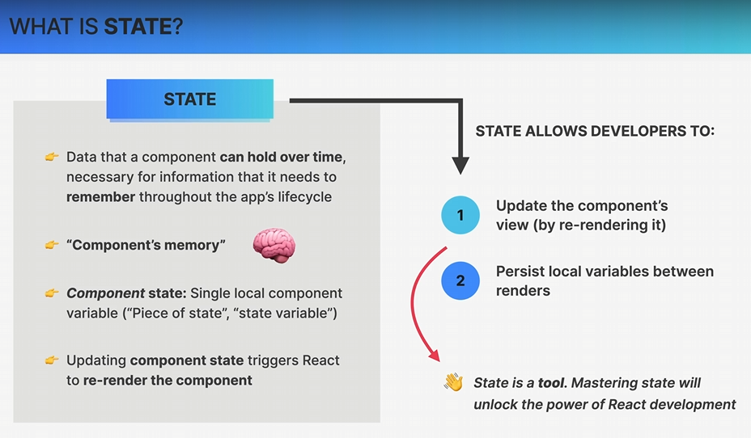

##### 

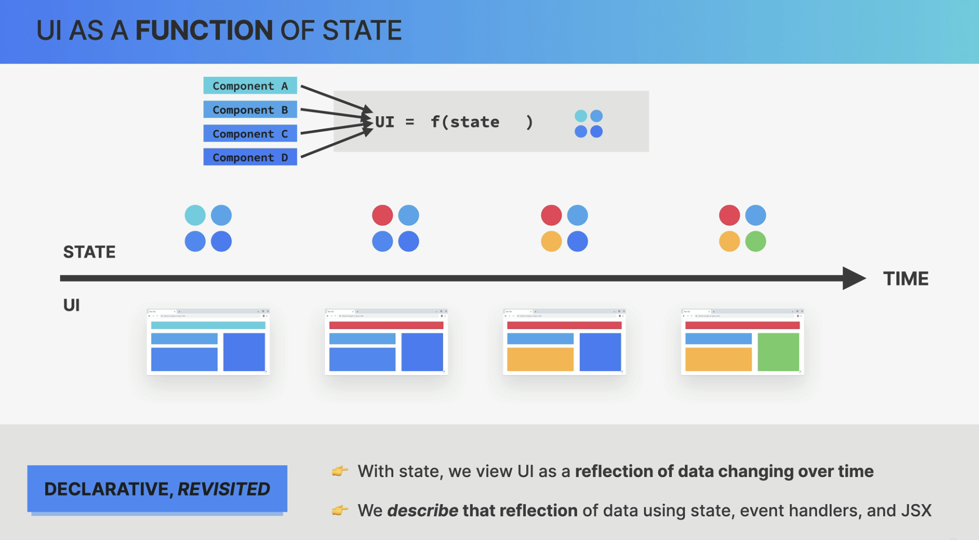

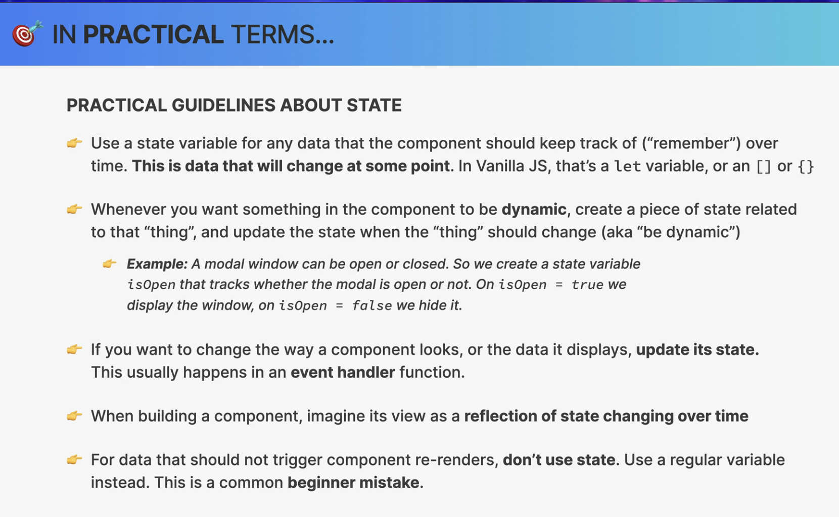

##### useState

So this useState here is a React function that returns an array.

And so here, we are destructuring that array.

So in the first position of the array, we have the value of the state that we call advice here.

The second value is a setter function.

So a function that we can use to update the piece of state.

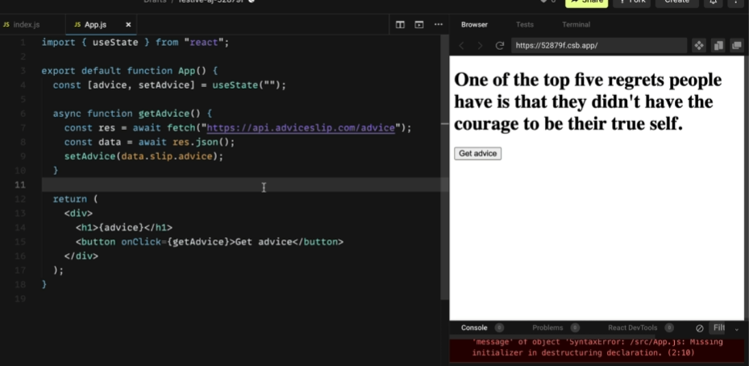

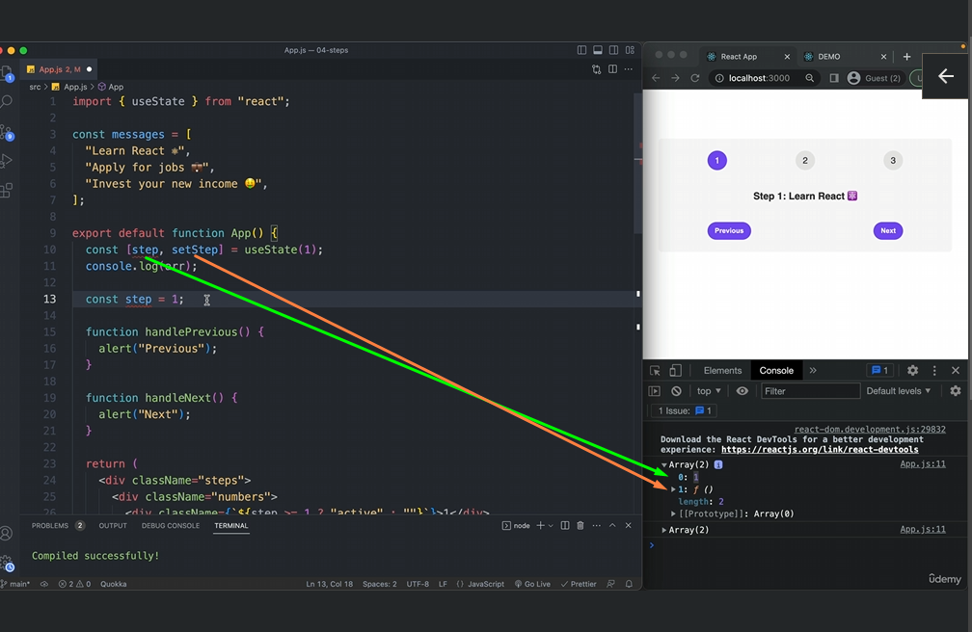

##### 

##### 

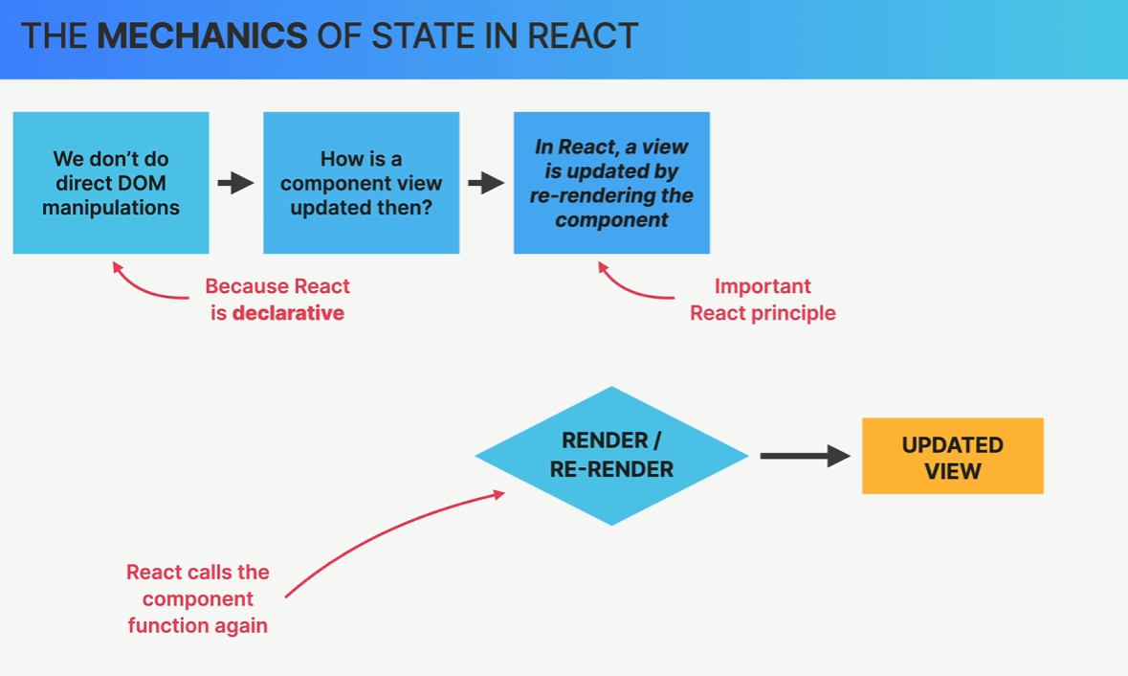

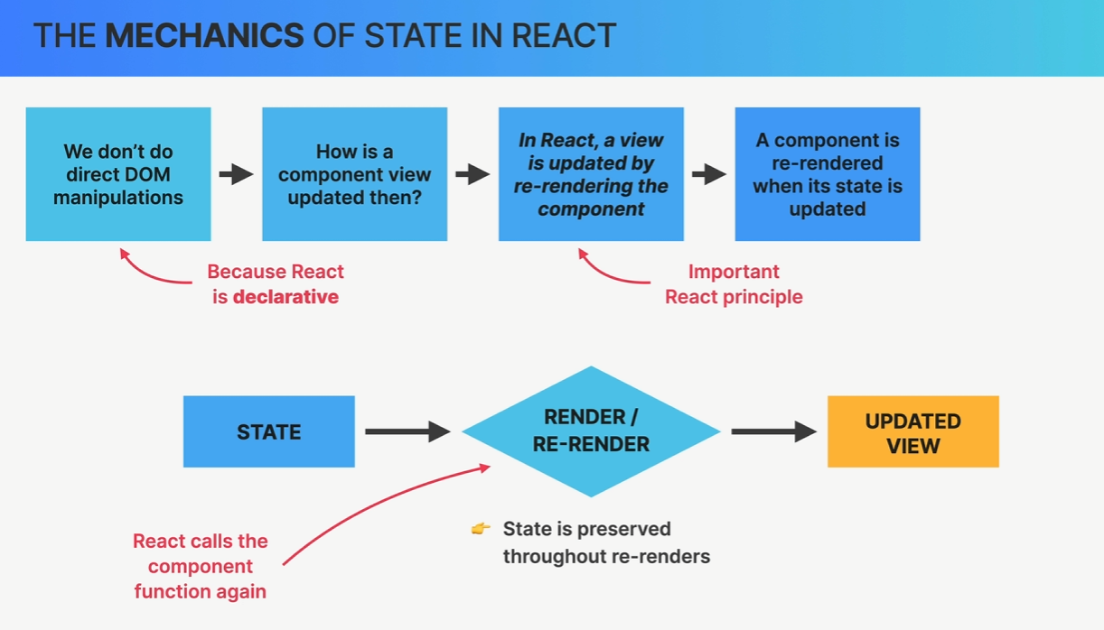

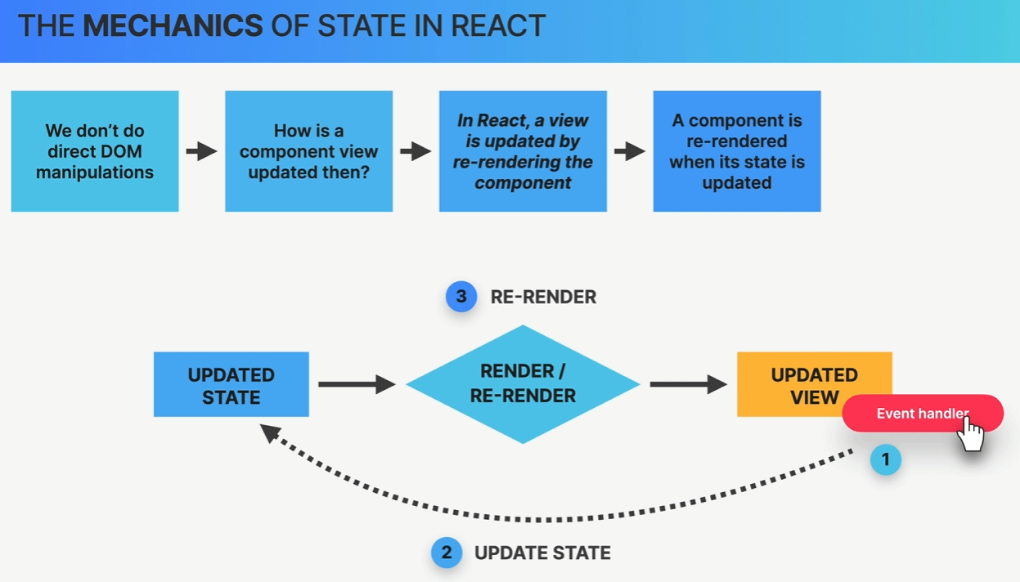

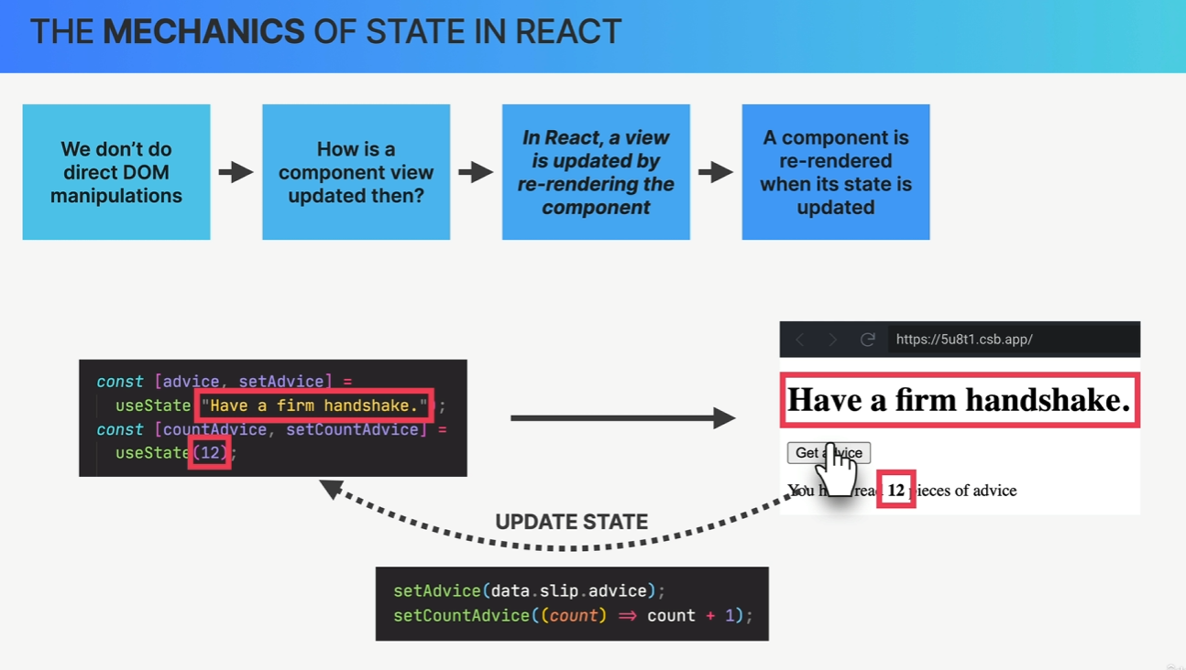

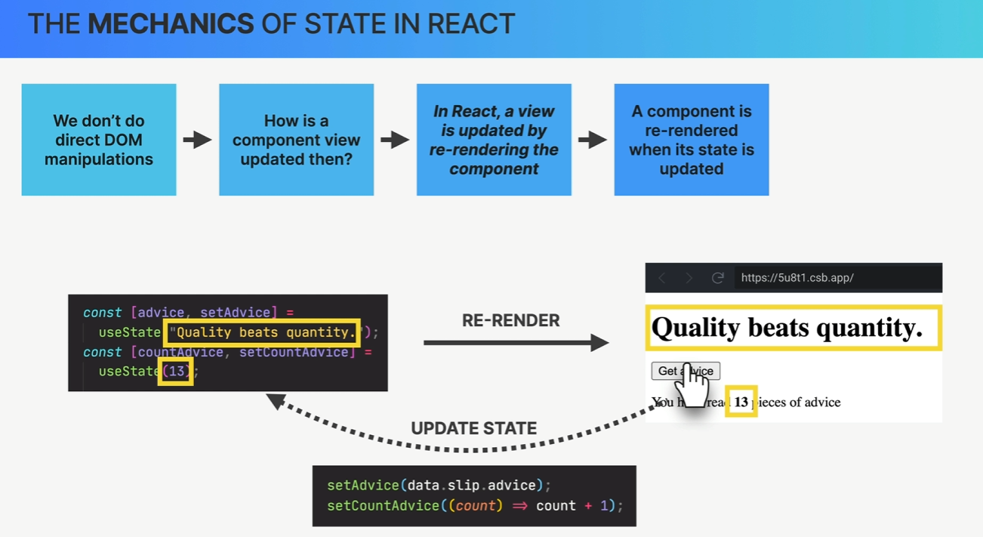

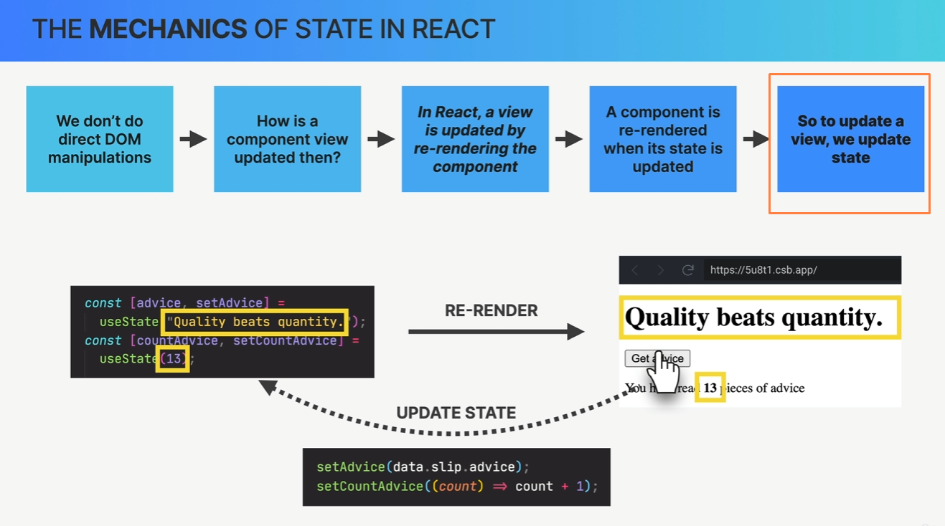

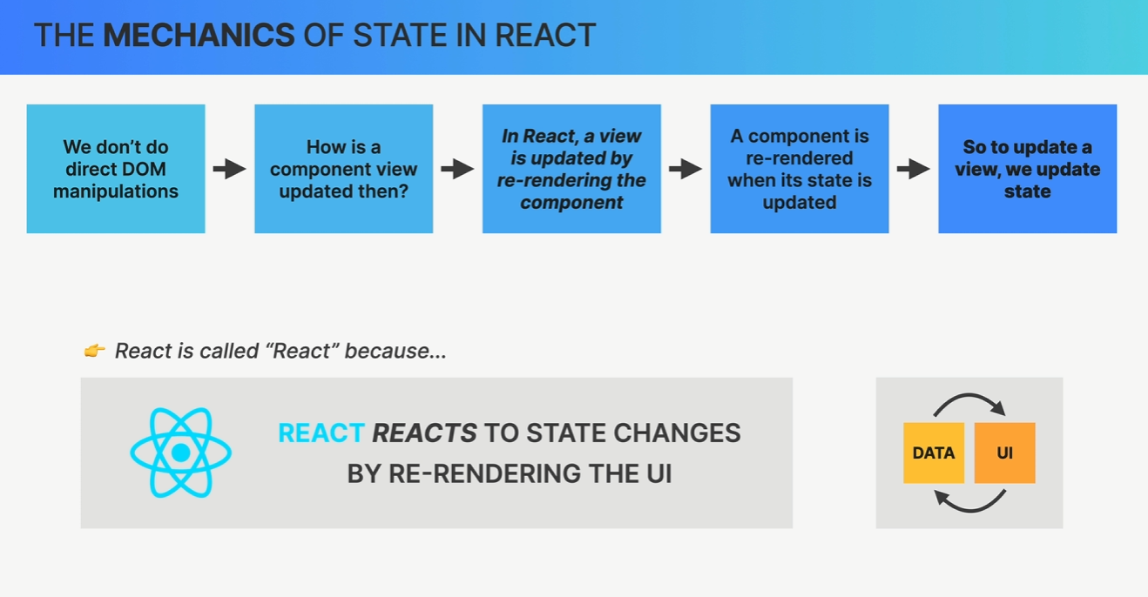

##### 

##### 

##### useEffect So useEffect takes two arguments. First, a function that we want to get executed at the beginning. So when this component first gets loaded. And then a second argument, which is called the dependency array.

#### Build our first react app

| import { useEffect } from "react"; import { useState } from "react";  function App() {  const [advice, setAdvice] = useState("");  const [count, setCount] = useState(0);  async function getAdvice() {  const res = await fetch("https://api.adviceslip.com/advice");  const data = await res.json();  setAdvice(data.slip.advice);  setCount((c) => c + 1);  }   useEffect(function () {  getAdvice();  }, []);   return (  <div>  <h1>{advice}</h1>  <button onClick={getAdvice}>Get advice</button>  <Message count={count} />  </div>  ); }  function Message(props) {  return (  <p>  You have read <strong>{props.count}</strong> pieces of advice  </p>  ); }  export default App; |
| --- |

#### Summary

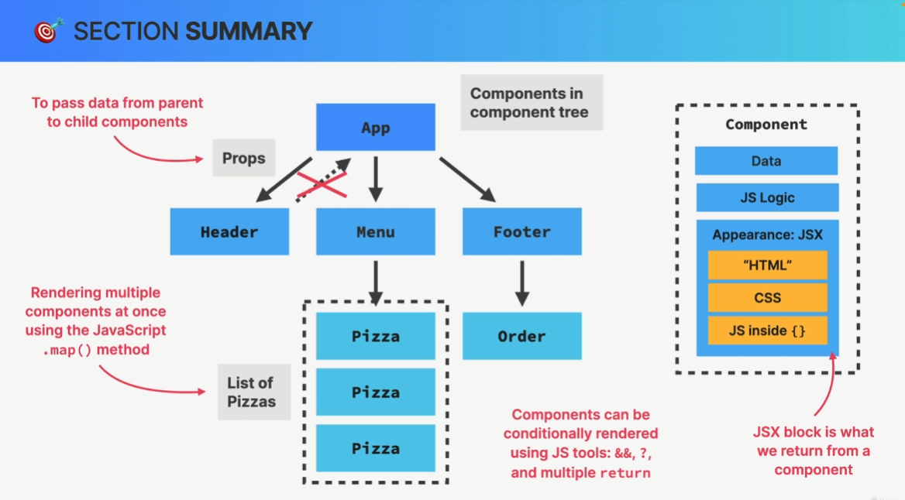

Section 6

#### Summary

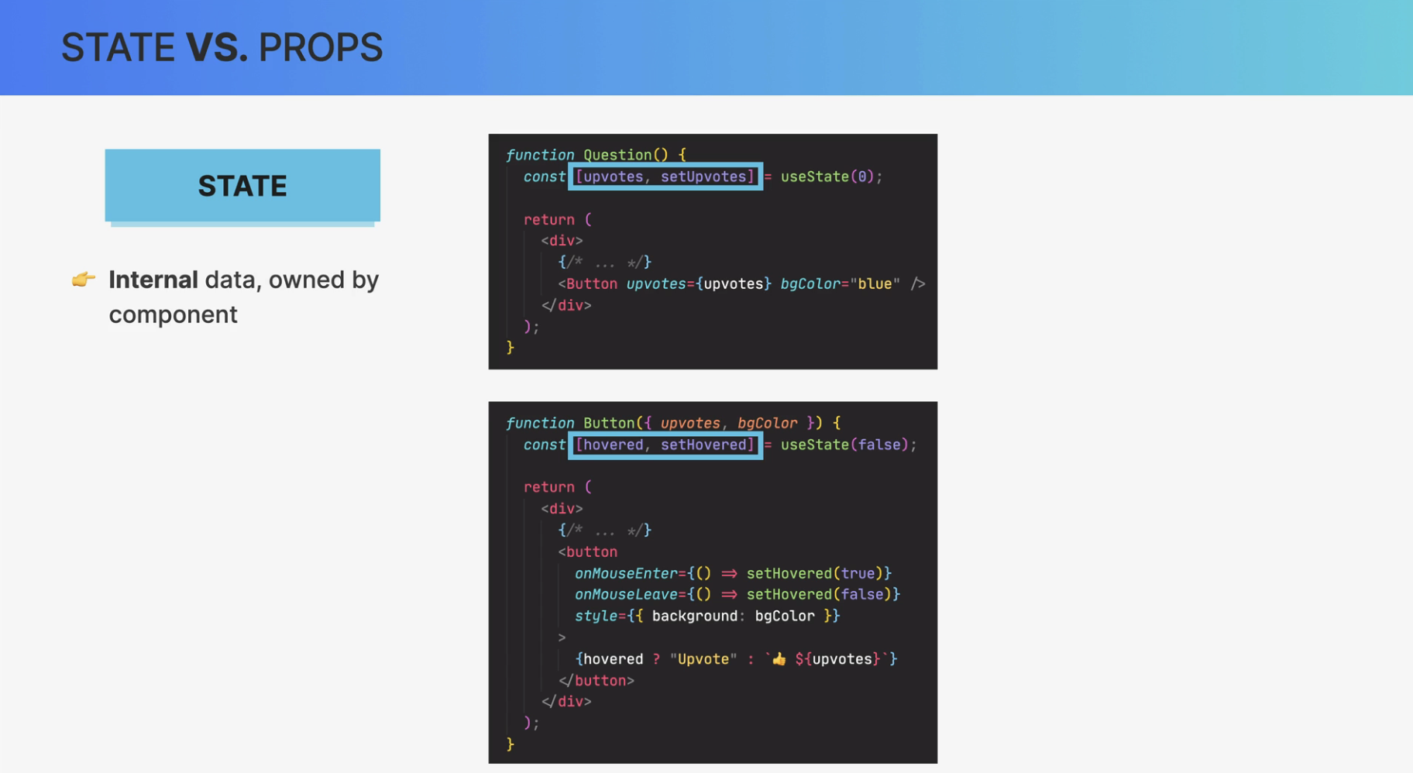

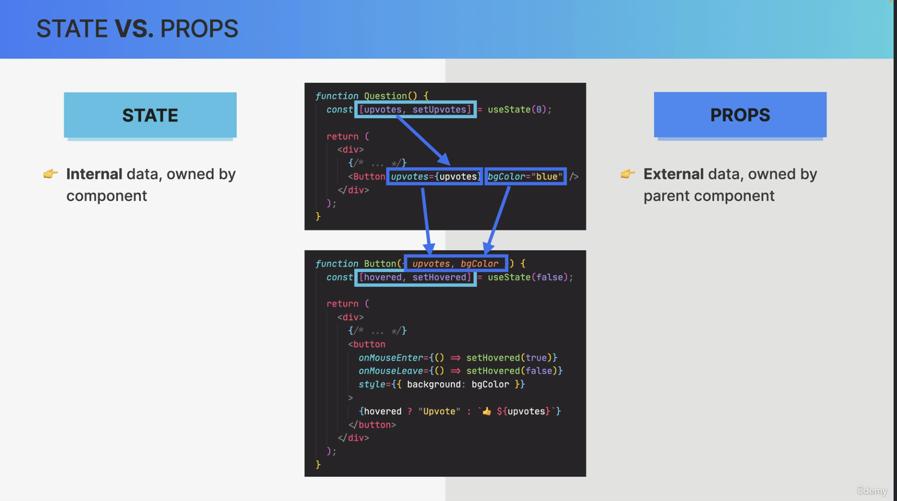

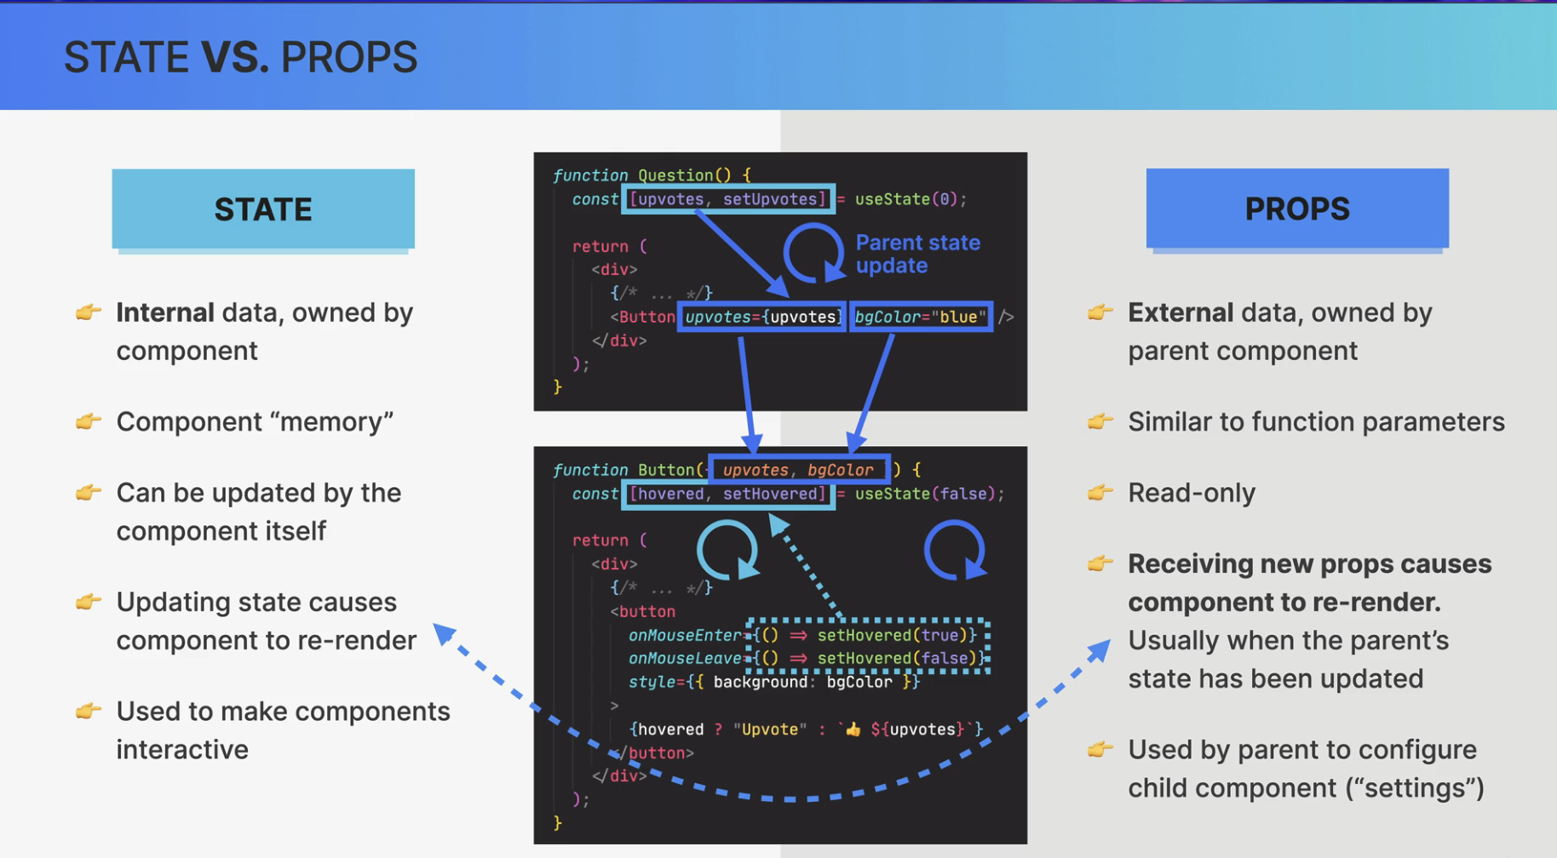

Section 7

#### Thinking in React

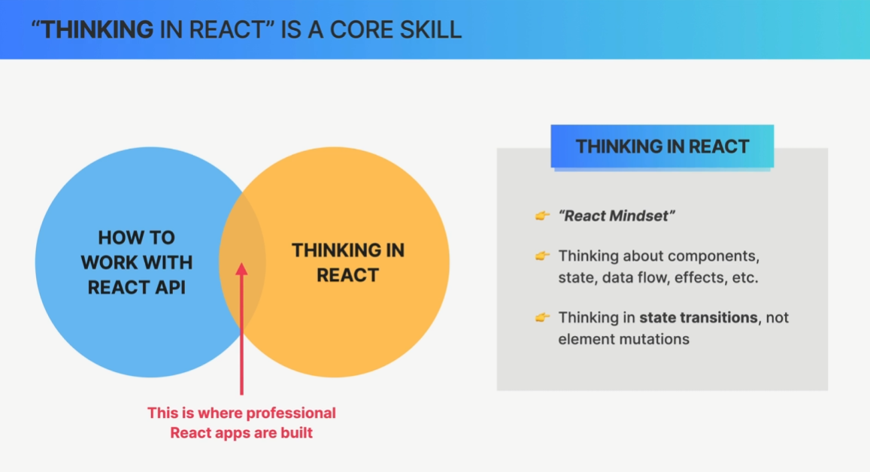

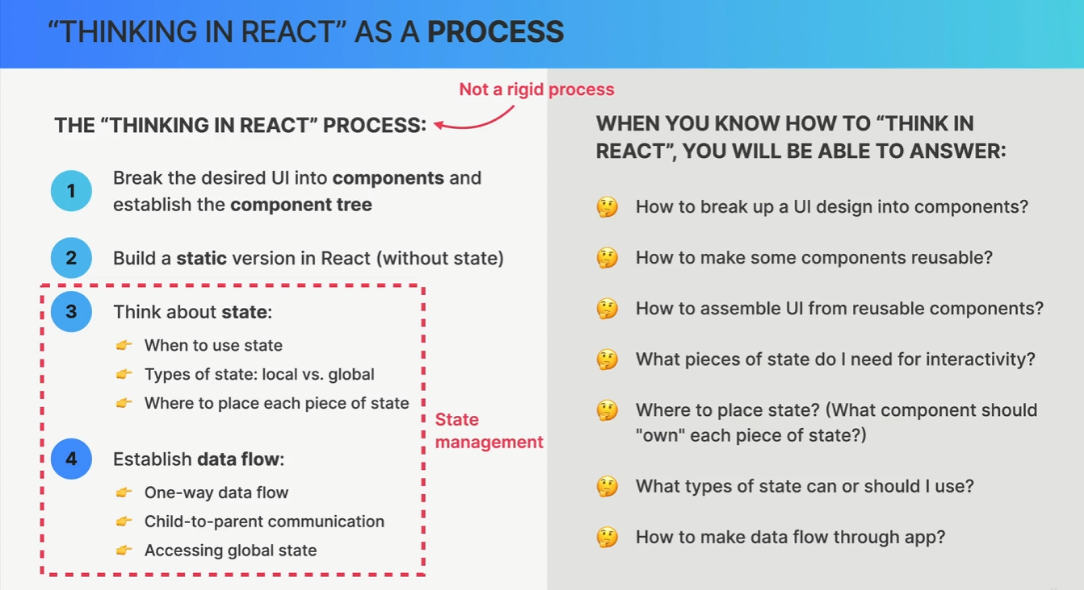

#### State Management

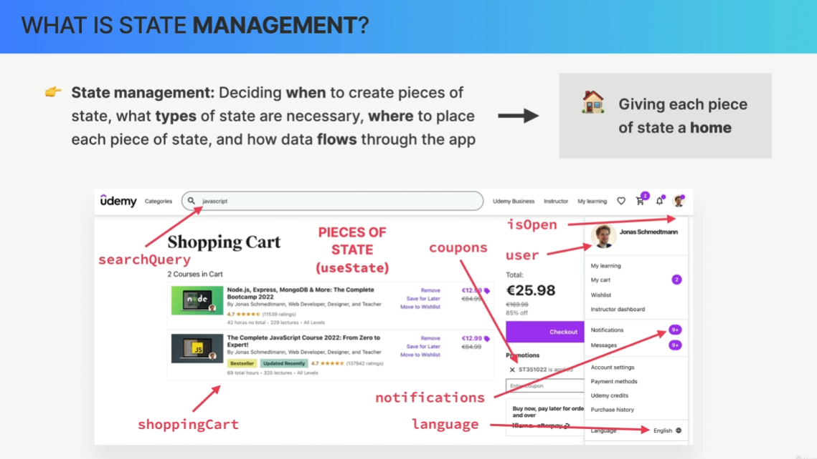

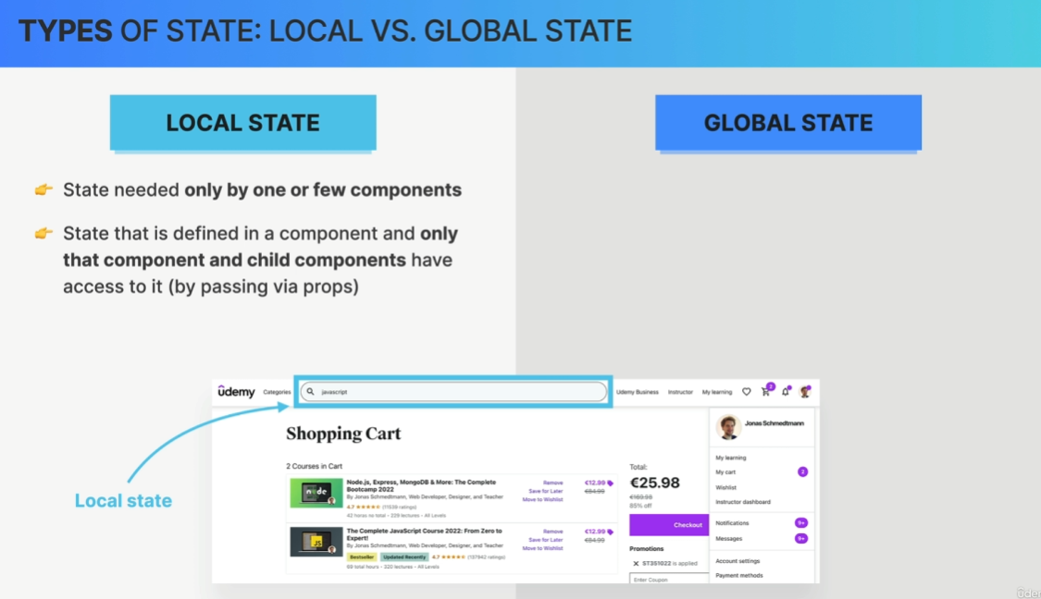

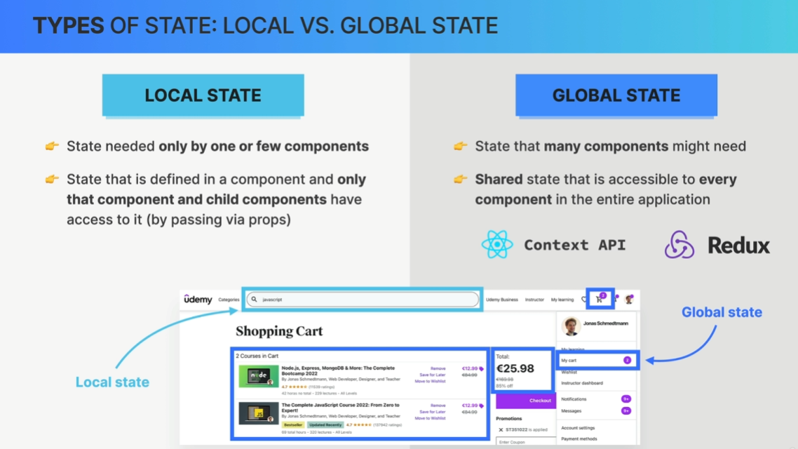

In fact, one important guideline in state management is to always start with local state

and only move to a global state if you truly need it.

